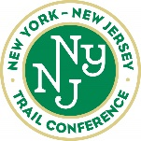
Standard paint colors

Standard paint colors recommended for general use on 2x3 blazes. Approved by Trails Council, June 10, 2020

DISCLAIMER: The colors represented either on screen or on your printer may not represent what they will look like on a tree)

It is more important that the color used on a single trail be uniform than that you exactly match one of these colors. If you don't know exactly what paint was used, repaint all the blazes. The colors change significantly upon drying so don't compare wet with dry.

- All the Standards and Alternates should be available in one-quart cans.
- Alternates are based on closest match and readily available colors.
- Latex-based exterior paint (or a paint with the primer already in it) should be used.
- Latex exterior enamel (high gloss or semi-gloss) is preferred for longevity.
- Many paint manufacturers, including Sherwin Williams, Benjamin Moore, Lowes Valspar and Home Depot Behr can mix colors of other manufacturers. Consider using that capability as a way to match the Trail Conference (TC) Standard Color, or if you have trouble finding a color. This is particularly relevant for the Long Path and Highlands Trail where the TC Standard Colors from Pittsburgh Paints and Dutch Boy, respectively, are not widely available. In particular Sherwin Williams, Benjamin Moore and Lowes Valspar can all match the TC Standard Colors for both the Long Path and Highlands Trails.
- Color samples obtained online and may not be true.

COLOR | TC STANDARD | ALTERNATES
WHITE | H-D/Behr 1850  Ultra Pure White | Or Any  True White
BLUE | Ben. Moore  0789  Sea to Shining Sea | Sher. Williams  SW6953  Candid Blue |  | H-D/Behr  530B-4  Bliss Blue |  | Lowes/Valspar  5002-9C  Summer Splash
BLUE | 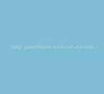 | 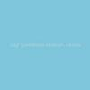 |  | 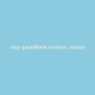 |  | 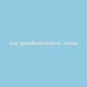
BLUE on  WHITE | Ben. Moore  0784  Blue Macaw | Sher. Williams  SW6796  Blue Plate |  | H-D/Behr  520B-7  Havasu |  | Lowes/Valspar  5004-8B  Tropical Oasis
BLUE on  WHITE | 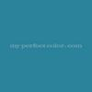 | 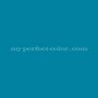 |  | 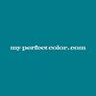 |  | 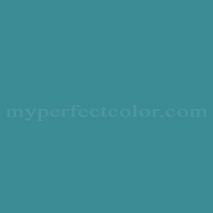
GREEN | Ben. Moore  0558  Killala Green | H-D/Glidden  34GY40/515  Topiary Green | H-D/Behr  S-G-420  Limeade |  | Lowes/Valspar  6005-10B  Jaunty Green
GREEN | 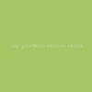 | 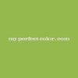 | 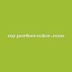 |  | 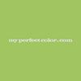
ORANGE | H-D/Behr  210B-7  Flame | H-D/Glidden  68YR28/701  Fiesta Orange | Sher. Williams  SW6868  Invigorate |  | Lowes/Valspar  2002-1A  Autumn Blaze
ORANGE | 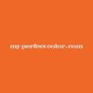 | 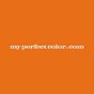 | 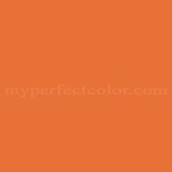 |  | 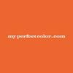
RED | Ben. Moore  2000-10  Red (Safety) | Sher. Williams  SW 6868  Real Red | H-D/Behr  8371  Candy Apple Red |  | Lowes/Valspar  1009-2  Classic Red
RED | 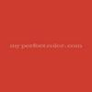 | 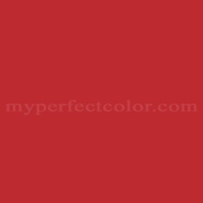 | 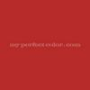 |  | 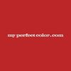
YELLOW | Ben. Moore  2022-20  Sun Kissed Yellow (Safety) | Sher. Williams  SW6906  Citrus | H-D/Behr  330B-7  Sunflower |  | Lowes/Valspar  3005-1A  Golden Delight
YELLOW |  |  | 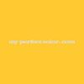 |  | 
PINK | Ben. Moore  2079-50  Rhododendron | Sher. Williams  SW6849  Party time | H-D/Behr  680A-3  Pink Bliss |  | Lowes/Valspar  1001-2A  Magic Wand
PINK | 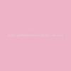 | 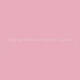 | 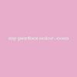 |  | 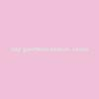

COLOR | TC STANDARD | ALTERNATES
PURPLE | Ben. Moore  2071-40  Crocus Petal Purple | Sher. Williams  SW6830  Kismet | Behr  P570-4  Classic Bouquet | Lowes/Valspar  4002-10B  Plum Burst
PURPLE | 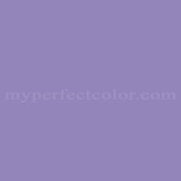 | 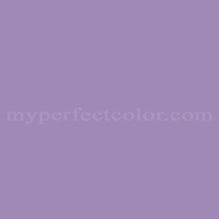 | 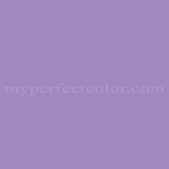 | 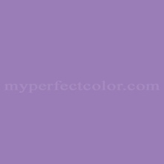
LONG  PATH | PPG 103-4 Tropical Tide  Moore, Lowes Valspar and Sherwin Williams can mix this color | H-D/Behr 470B-4 Intense Jade
LONG  PATH | 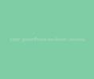 | 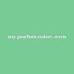
HIGHLANDS  TRAIL | Dutch Boy10F-5  (11-B-5) Lake Superior  Moore, Lowes Valspar and Sherwin Williams can mix this color | H-D/Behr  490B-5  Cozumel | Lowes/Valspar  5006-10B  Turquoise Tint | Ben. Moore  733  Palm Coast Teal
HIGHLANDS  TRAIL | 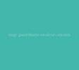 | 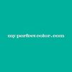 | 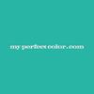 | 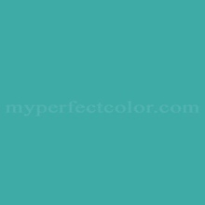

- Spray paint may be used to neutralize, block-out or paint over old blazes that are no longer in use.
- Neutralizing or Block-out colors are suggestions only. Your choice will depend on the species and age of the trees or rock color. Some trees, such as, Chestnut Oak will require a darker charcoal gray color.
- Spray paints are preferred in matte finish.

NEUTRALIZING | TC STANDARD | ALTERNATES
DARK | Ben. Moore 1491  Aegean Olive | SPRAYCAN  Rustoleum 2X Ultra Cover, Dark Walnut, Kona Brown or Satin Epresso  Krylon 4292 Brown | H-D/Behr 780D-7  Wild Rice | H-D/Behr 420F-7  Forest Ridge
DARK | 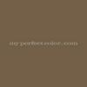 |  | 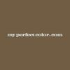 | 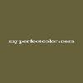
MEDIUM | Ben. Moore  2139-30 Sharkskin | SPRAY CAN  Rustoleum 2X Ultra Cover Chestnut  Krylon 4293  Olive | H-D/Behr 790D-6  Dusty Mountain | H-D/Behr 720F-4  Stone Fence
MEDIUM | 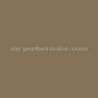 |  |  | 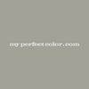
LIGHT | H-D/Behr  770E-3  Pewter Mug | SPRAY CAN  For Gray:  (& for rocks)  Rustoleum 2X Ultra Cover  Satin Granite | SPRAYCAN  For Beige: Rustoleum Khaki | H-D/Behr  790E-2  Gentle Rain
LIGHT | 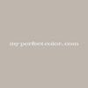 |  | 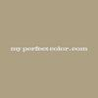 | 